PROJECT REPORT
NETWORK REQUEST
MANAGEMENT
ServiceNow Service Catalog & Network Request Automation

PROJECT INFORMATION | DETAILS
Project Title | Automated Network Request & Fulfillment Management System
Student Name | Bantupalli Niharika
Technology | ServiceNow
Application | Network Request Management
Date | 6 September 2026

SUBMITTED AS A PROJECT DOCUMENTATION REPORT

00 TABLE OF CONTENTS
Automated Network Request & Fulfillment Management System
SECTION | PAGE
1. Introduction | 3
2. Ideation Phase | 4
3. Requirement Analysis | 5
4. Data Flow and Technology Stack | 6
5. Project Design and Architecture | 7
6. Project Planning and Scheduling | 8
7. Functional Testing and UAT | 9
8. Performance Testing and Results | 10
9. Output Screenshots | 11–12
10. Work Item Validation, Advantages and Limitations | 13
11. Conclusion and Future Scope | 14
12. Appendix and References | 15

Project at a Glance
The project provides a centralized ServiceNow catalog-based process for employees to submit network service requests. It uses catalog variables, UI Policies, approval processing and Flow Designer automation to support request fulfillment.
CORE COMPONENT | ROLE
Service Portal / Service Catalog | Employee-facing request entry point
Catalog Variables & UI Policies | Capture information and guide form behaviour
Approval Process | Routes submitted requests for approval
Flow Designer | Automates workflow actions
Network Task | Tracks work assigned to the fulfillment team

01 INTRODUCTION

1.1 Project Overview
The Automated Network Request & Fulfillment Management System is a ServiceNow-based solution intended to provide employees with a centralized method for requesting network-related services. Employees access a Network Request Catalog Item through the Service Portal and enter the information required to process the request.
Catalog variables capture request details. Catalog UI Policies support dynamic form behaviour and mandatory-field validation. After submission, ServiceNow creates request records (REQ and RITM). The request is routed for approval; after approval, a Network Task is created and assigned to the Network Fulfillment Team for processing.

1.2 Purpose and Objectives
The purpose is to standardize network-service request submission and provide a traceable process from request entry to fulfillment. The project objectives are:
- Provide a single catalog entry point for network requests.
- Capture relevant and complete request information.
- Use form validation to reduce incomplete submissions.
- Route requests through an approval process.
- Create fulfillment tasks after approval.
- Assign tasks to the Network Team and improve request visibility.

1.3 Scope
The project scope includes the Service Catalog item, catalog variables, Catalog UI Policies, approval processing, Flow Designer automation, Network Task creation, group assignment and basic workflow validation. Large-scale concurrent-user load testing and advanced external integrations are outside the documented completed scope.

1.4 High-Level Workflow
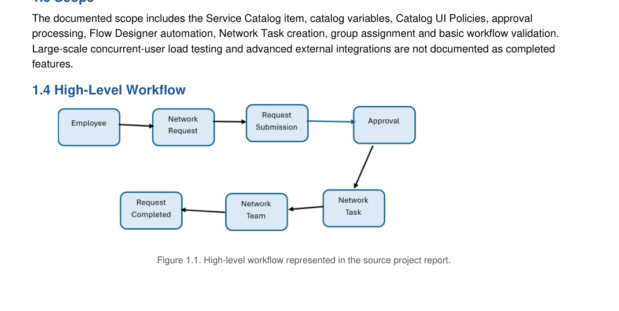
Figure 1.1. High-level workflow from employee request submission through approval and network fulfillment.

02 IDEATION PHASE

2.1 Problem Statement
Employees may experience difficulty when requesting network-related services if request channels and forms are unclear or unstructured. Missing information can lead to clarification cycles, while manual routing can delay approval and fulfillment. The project addresses this by providing a guided catalog item and a defined processing workflow.
PARAMETER | DESCRIPTION
User | Employees requesting network services
Problem | Network requests may be unclear or incomplete
Need | A simple and structured request process
Impact | Delays in approval and fulfillment
How might we? | How might we provide a centralized system for submitting and managing network requests efficiently?

2.2 Empathy Map – Employee Perspective
DIMENSION | EMPLOYEE PERSPECTIVE
Says | I need a simple way to request network services.
Thinks | I want a clear form with relevant options.
Does | Opens the portal, selects Network Request and submits details.
Feels | Wants fast and reliable network support.
Pain points | Incomplete requests, unclear forms and delayed processing.
Needs / goals | Simple submission, clear tracking and timely fulfillment.

2.3 Brainstorming and Prioritization
IDEA / FEATURE | PRIORITY
Network Request Catalog Item | High
Catalog Variables | High
Catalog UI Policies | High
Approval Process | High
Flow Designer Automation | High
Network Task Creation | High
Network Team Assignment | High
Request Status Tracking | Medium
Notifications | Medium
Reports and Dashboards | Medium

The high-priority features were selected for the initial implementation because they directly support the core request and fulfillment workflow.

03 REQUIREMENT ANALYSIS

3.1 Customer Journey Map
STAGE | EMPLOYEE ACTION | SYSTEM RESPONSE
Access | Opens Service Portal | Portal displays available services
Discover | Finds Network Request | Catalog item is displayed
Submit | Enters request details | Variables capture information
Validate | Completes required fields | UI Policies validate the form
Process | Submits request | REQ and RITM are created
Approval | Waits for approval | Approval workflow is triggered
Fulfillment | Request is processed | Network Task is created
Completion | Receives completed service | Request status is updated

3.2 Functional Requirements
ID | REQUIREMENT
FR-01 | Employees shall be able to access the Network Request Catalog Item.
FR-02 | The system shall capture the required request information.
FR-03 | The system shall validate mandatory fields.
FR-04 | Relevant fields shall be displayed dynamically where configured.
FR-05 | The system shall create request records after submission.
FR-06 | The request shall be sent for approval.
FR-07 | A Network Task shall be created after approval.
FR-08 | The Network Team shall process the assigned task.

3.3 Non-Functional Requirements
ID | REQUIREMENT
NFR-01 | The system should provide a simple user interface.
NFR-02 | The system should use ServiceNow access controls.
NFR-03 | The workflow should process requests consistently.
NFR-04 | The system should provide normal ServiceNow response performance.

04 DATA FLOW AND TECHNOLOGY STACK

4.1 Logical Data Flow Diagram
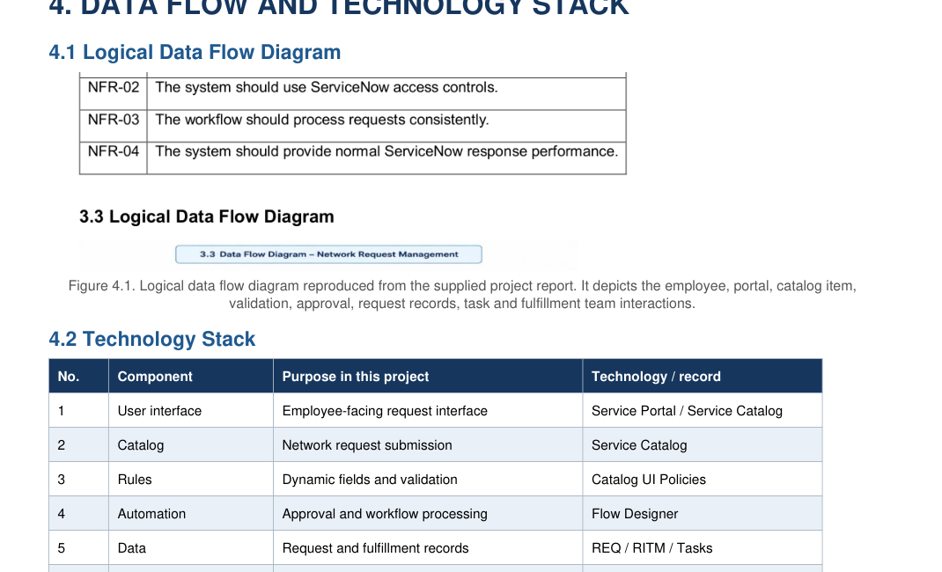
Figure 4.1. Logical data flow showing employee, portal, catalog item, validation, approval, request records, task and fulfillment team interactions.

4.2 Technology Stack
NO. | COMPONENT | PURPOSE IN THIS PROJECT | TECHNOLOGY / RECORD
1 | User interface | Employee-facing request interface | Service Portal / Service Catalog
2 | Catalog | Network request submission | Service Catalog
3 | Rules | Dynamic fields and validation | Catalog UI Policies
4 | Automation | Approval and workflow processing | Flow Designer
5 | Data | Request and fulfillment records | REQ / RITM / Tasks
6 | References | User and group information | sys_user / sys_user_group

4.3 Data and Record Notes
The system uses REQ and RITM request records and Network Tasks as the principal records involved in the documented workflow. It also uses sys_user and sys_user_group as reference data for users and assignment groups.

05 PROJECT DESIGN AND ARCHITECTURE

5.1 Problem–Solution Fit
PARAMETER | PROJECT FIT
Problem | Employees need a simple and structured way to submit network requests.
Solution | A ServiceNow-based Network Request Management system.
Customer benefit | Guided request entry and better request visibility.
Operational benefit | Structured requests improve approvals and fulfillment.
Uniqueness | Combines Service Catalog, UI Policies, approvals and task automation.
Scalability | Additional request types and automation can be added later.

5.2 Proposed Solution
Employees submit network-related requests through a Network Request Catalog Item. Catalog variables capture request information, while Catalog UI Policies provide dynamic form behaviour and validation. After submission, the request is processed through an approval workflow. Once approved, a Network Task is created and assigned to the Network Fulfillment Team.

5.3 Solution Architecture
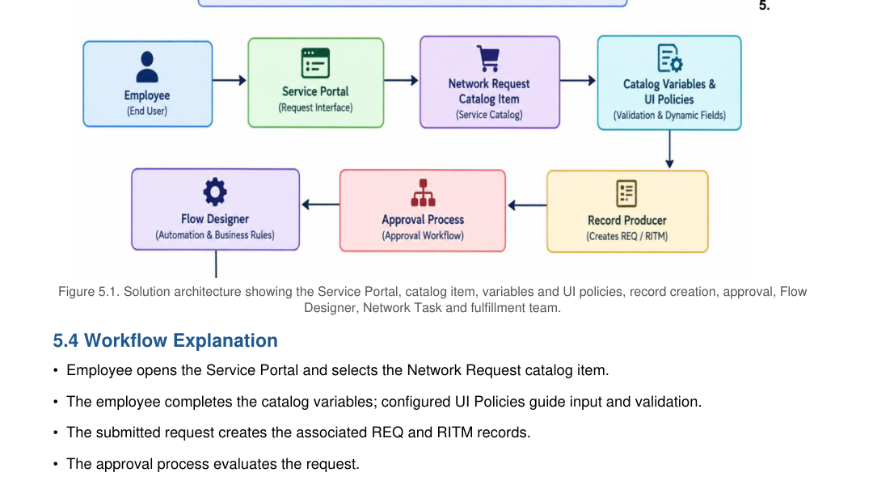
Figure 5.1. Solution architecture connecting the Service Portal, catalog item, variables and UI policies, record creation, approval, Flow Designer, Network Task and fulfillment team.

5.4 Workflow Explanation
- Employee opens the Service Portal and selects the Network Request catalog item.
- The employee completes the catalog variables; configured UI Policies guide input and validation.
- The submitted request creates the associated REQ and RITM records.
- The approval process evaluates the request.
- Following approval, the automation creates a Network Task and assigns it to the Network Team.
- The fulfillment team processes the task and the request is updated to its completed state.

06 PROJECT PLANNING AND SCHEDULING

6.1 Sprint Plan
SPRINT | FUNCTIONAL AREA | USER STORY / TASK | POINTS | PRIORITY | ASSIGNED STUDENT
1 | Foundation | Create Network Request components and fields | 6 | High | Bantupalli Niharika
2 | Catalog & rules | Create catalog item, variables and UI Policies | 6 | High | Bantupalli Niharika
3 | Automation | Configure approvals and Network Task creation | 6 | High | Bantupalli Niharika
4 | Testing | Testing and documentation | 2 | High | Bantupalli Niharika

6.2 Implementation Activities
The project plan is organized into four sequential work areas. The foundation sprint establishes the request components and fields. The catalog and rules sprint configures the user-facing item, variables and UI Policies. The automation sprint configures approval and task creation. The final sprint focuses on testing and documentation.

6.3 Planning Notes
The sprint plan identifies the functional areas, tasks, story points, priorities and assigned student. Sprint dates and actual completion dates are not specified.

07 FUNCTIONAL TESTING AND USER ACCEPTANCE TESTING

7.1 Functional Testing
TEST ID | SCENARIO | EXPECTED RESULT | STATUS
TC-01 | Open Service Portal | Portal loads successfully | Pass
TC-02 | Find Network Request | Catalog item is visible | Pass
TC-03 | Open request form | Form opens successfully | Pass
TC-04 | Enter request details | Variables are available | Pass
TC-05 | Select device type | Relevant options display | Pass
TC-06 | Validate fields | Mandatory validation works | Pass
TC-07 | Submit request | REQ and RITM are created | Pass
TC-08 | Approval process | Request goes for approval | Pass
TC-09 | Create Network Task | Task is created | Pass
TC-10 | End-to-end test | Complete workflow works | Pass

7.2 User Acceptance Testing (UAT)
UAT ID | SCENARIO | ACCEPTANCE CRITERIA | RESULT
UAT-01 | Open Service Portal | Portal accessible | Accepted
UAT-02 | Find Network Request | Catalog item visible | Accepted
UAT-03 | Open form | Request form opens | Accepted
UAT-04 | Select Device Type | Option selectable | Accepted
UAT-05 | Validate fields | Required validation works | Accepted
UAT-06 | Submit request | Request created | Accepted
UAT-07 | Approval | Approval works | Accepted
UAT-08 | Task creation | Task assigned | Accepted
UAT-09 | Complete request | Request completed | Accepted

7.3 UAT Conclusion
The functional test cases are recorded as Pass and the UAT cases are recorded as Accepted.

08 PERFORMANCE TESTING AND RESULTS

8.1 Performance Testing
The implemented workflow was tested for normal interactive usage within the ServiceNow Personal Developer Instance. The application successfully handled the following activities:
- Catalog form loading.
- Request submission.
- Validation processing.
- Approval workflow execution.
- Network Task creation.
Testing limitation: Large-scale concurrent-user load testing was outside the scope of the project.

8.2 Performance Evidence and Reporting
Measured response times, throughput, concurrent-user counts, CPU or memory utilization, and load-test tool output are not included. Therefore, no numerical performance claim is made in this report.

8.3 Results Summary
AREA | RESULT
Catalog item | Created
Catalog variables | Required fields configured
UI Policies | Dynamic behaviour configured
Approval process | Approval configured
Flow Designer | Workflow automation configured
Network Tasks | Tasks created for fulfillment
Service Portal | Catalog accessible
Testing | Workflow validated

The core workflow components were configured and validated in the project environment.

09 OUTPUT SCREENSHOTS
ServiceNow configuration and employee request interface

9.1 Network Request Catalog Item
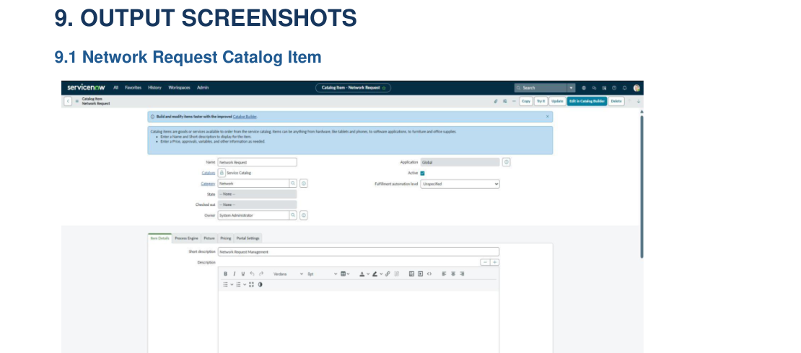
Figure 9.1. Network Request Catalog Item configuration screen.

9.2 Network Request Form
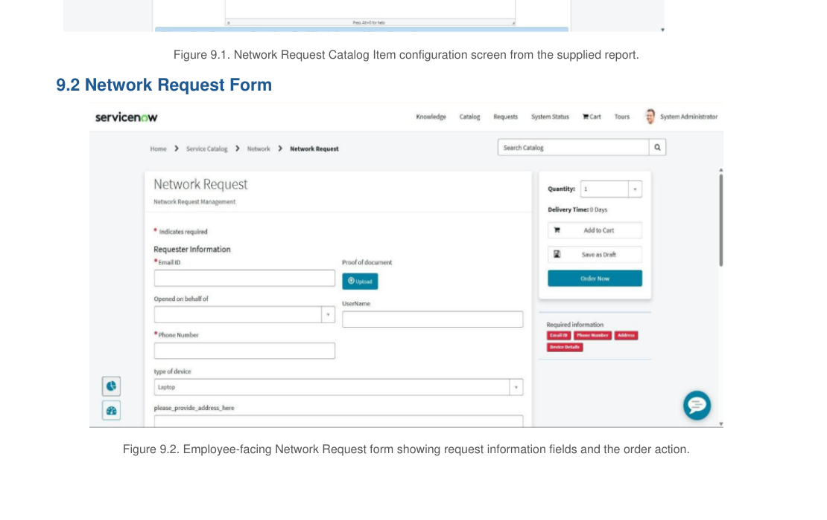
Figure 9.2. Employee-facing Network Request form showing request information fields and the order action.

09 OUTPUT SCREENSHOTS – CONTINUED
Request submission and notification evidence

9.3 Submitted Network Request Record
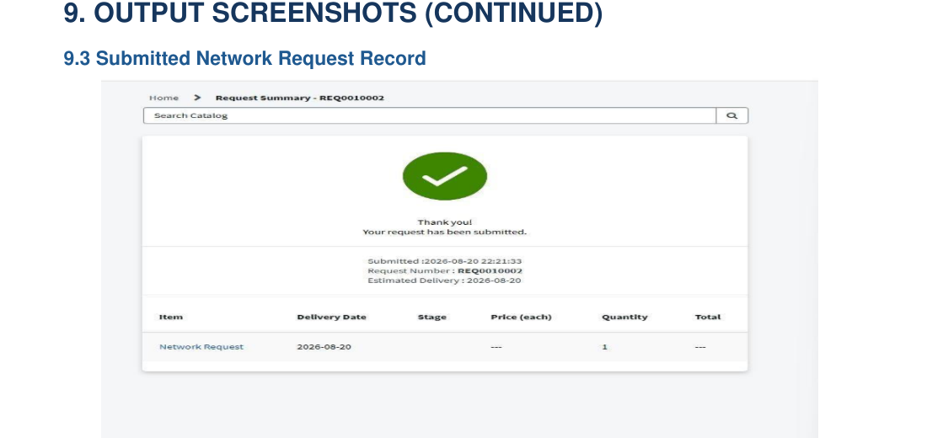
Figure 9.3. Request submission confirmation and summary record.

9.4 Email Notification
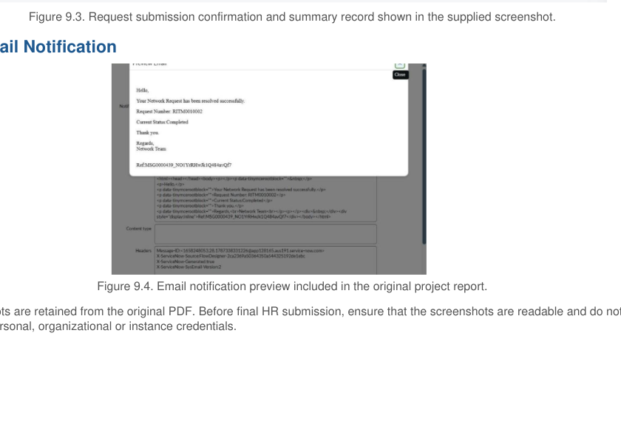
Figure 9.4. Email notification preview.

10 WORK ITEM VALIDATION, ADVANTAGES AND LIMITATIONS

10.1 Work Item Status Validation
WORK ITEM | STATUS | VALIDATION
Network Request Catalog | Completed | Catalog item created
Catalog Variables | Completed | Required fields configured
UI Policies | Completed | Dynamic behaviour configured
Approval Process | Completed | Approval configured
Flow Designer | Completed | Workflow automation configured
Network Tasks | Completed | Tasks created for fulfillment
Service Portal | Completed | Catalog accessible
Testing | Completed | Workflow validated

10.2 Advantages
- Provides centralized network request submission.
- Reduces incomplete request information.
- Improves request standardization.
- Automates approvals and task creation.
- Improves visibility into the request lifecycle.
- Reduces manual effort for the Network Team.

10.3 Limitations / Disadvantages
- Depends on correct ServiceNow configuration.
- Initial configuration requires platform knowledge.
- Complex workflows may require additional maintenance.
- Advanced integrations may require additional development.
- Large-scale concurrent-user performance was not tested within the documented scope.

11 CONCLUSION AND FUTURE SCOPE

11.1 Conclusion
The Automated Network Request & Fulfillment Management System demonstrates a structured approach to managing network service requests using ServiceNow. Employees can submit requests through a centralized catalog, provide required information, and benefit from configured validation and approval processing. Following approval, the workflow creates a Network Task for fulfillment by the Network Team.
The project brings together ServiceNow Service Catalog, Catalog UI Policies, Flow Designer, approval processing and task management to support a more consistent request lifecycle. The test outcomes and screenshots provide evidence for the implemented scope.

11.2 Future Scope
- Email and mobile notifications.
- Advanced dashboards and reporting.
- Service Level Agreement (SLA) monitoring.
- Additional network service categories.
- Automatic priority calculation.
- Integration with external network monitoring tools.
- AI-based request classification.
- Virtual Agent support.
- Knowledge articles for common network issues.

12 APPENDIX AND REFERENCES

Appendix A – Technology Components
NO. | COMPONENT
1 | ServiceNow Service Catalog
2 | Catalog Items
3 | Catalog Variables
4 | Catalog UI Policies
5 | Flow Designer
6 | Approval Engine
7 | REQ and RITM Records
8 | Network Tasks
9 | sys_user
10 | sys_user_group

Appendix B – Project Flow
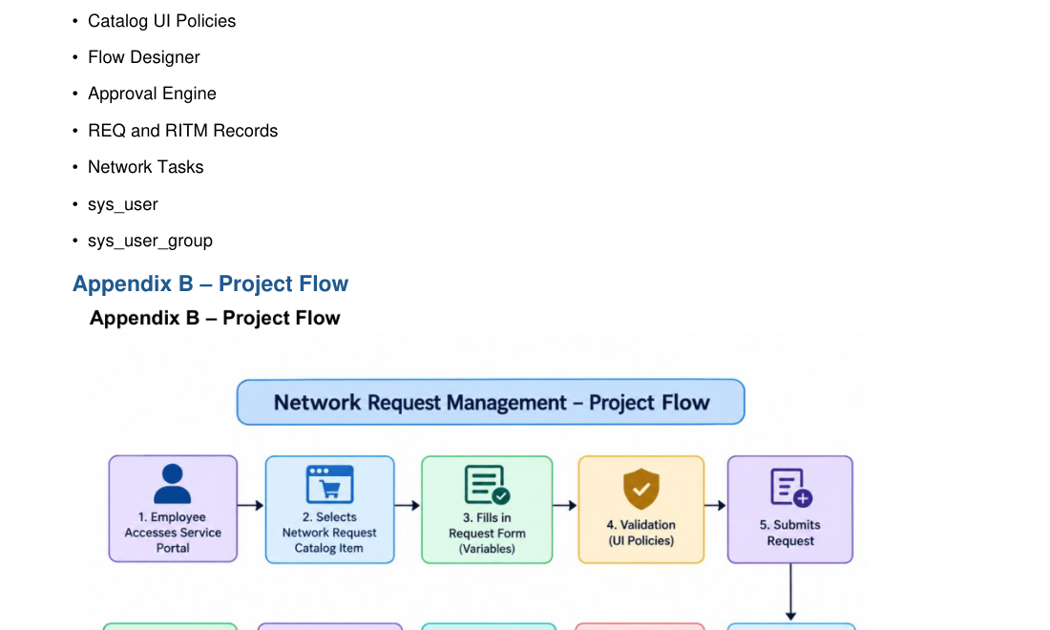
Figure 12.1. End-to-end project flow.

Appendix C – Acronyms
TERM | MEANING
REQ | Request record
RITM | Requested Item record
UAT | User Acceptance Testing
UI | User Interface
SLA | Service Level Agreement
DFD | Data Flow Diagram

